 

# Placement Empowerment Program

***Cloud Computing and DevOps Centre***

Back Up and Restore a Cloud Instance : Take a snapshot of your cloud VM. Terminate the VM and restore it from the snapshot.

Name: Shahana.M.S Department: ADS



**Introduction**

Backing up and restoring cloud instances is a critical aspect of cloud management that ensures data protection, disaster recovery, and business continuity. By taking a snapshot of a virtual machine (VM), users can create a point-in-time backup that can be used to restore the instance in case of failure, accidental deletion, or data corruption. Cloud providers like AWS, Azure, and Google Cloud Platform (GCP) offer built-in tools to create, manage, and restore snapshots efficiently.

**Overview**

A snapshot is a full copy of a VM’s disk at a given moment, allowing users to restore the system to that exact state when needed. Cloud snapshots are typically stored in cloud storage and can be used to create new instances or restore existing ones. The backup and restore process involves:

* **Taking a Snapshot** – Capturing the current state of a VM, including its OS, applications, and data.
* **Terminating the VM** – Deleting or shutting down the instance to simulate a failure or test recovery.
* **Restoring from Snapshot** – Creating a new VM from the saved snapshot, ensuring minimal downtime and data loss.

**Objective**

* To create a snapshot of a cloud VM for backup purposes.
* To simulate failure by terminating the VM.
* To restore the VM from the snapshot and verify that all data and configurations are intact.
* To understand the importance of automated backup strategies for cloud workloads.

# Step-by-Step Overview

## Step 1:

* 1. Go to [AWS Management Console](https://aws.amazon.com/console/).
  2. Enter your username and password to log in.

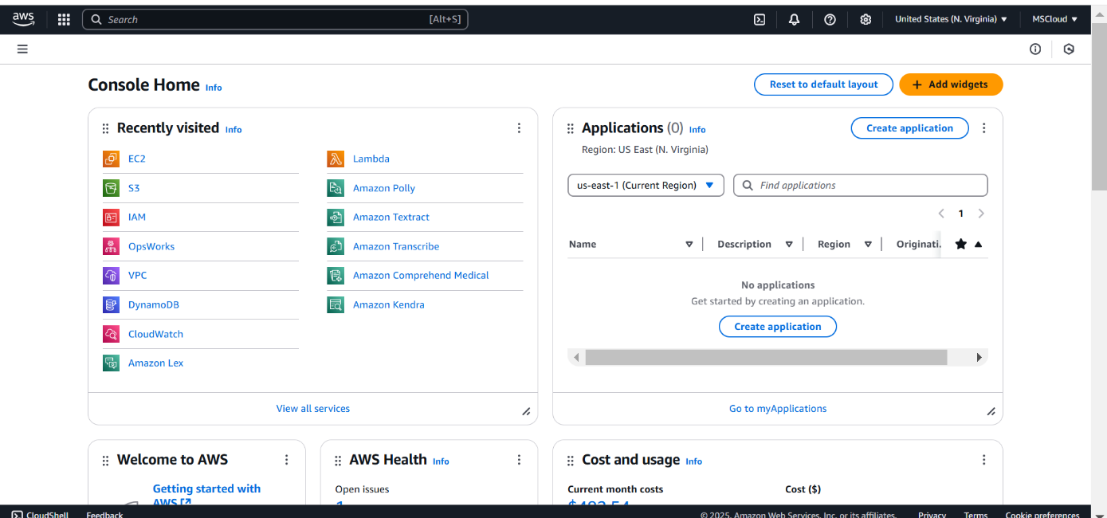

## Step 2:

Launch an Ec2 instance.(Backup Instance)

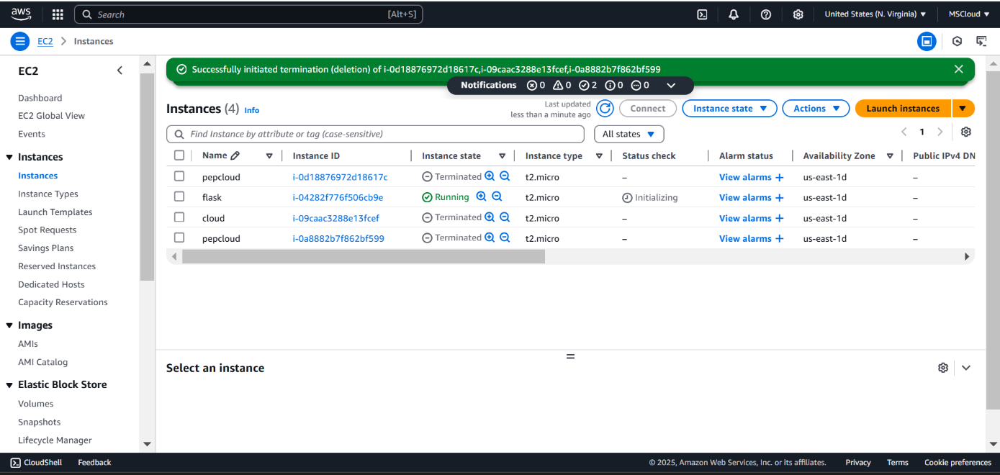

## Step 3:

Create volume is under EBS and in here you use gp3 and here you can also attach volume as shown in here:

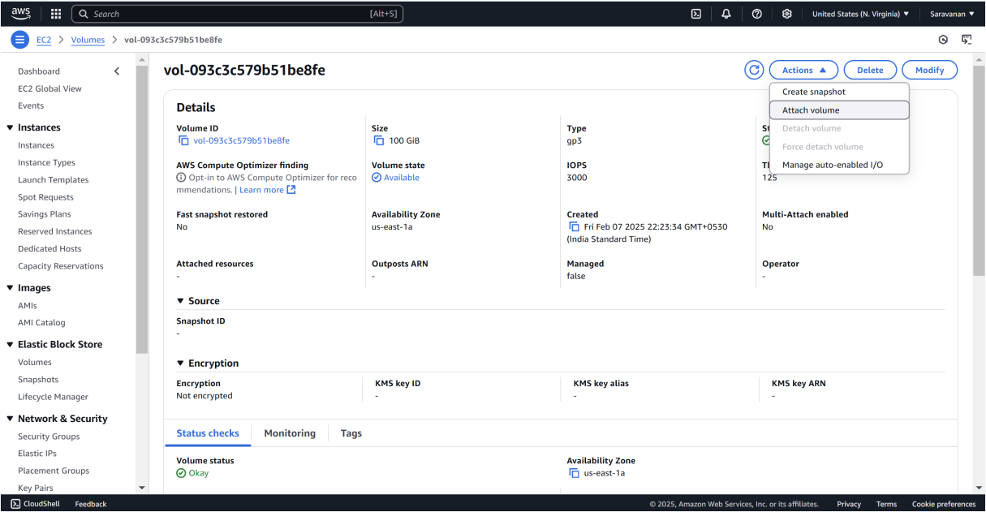

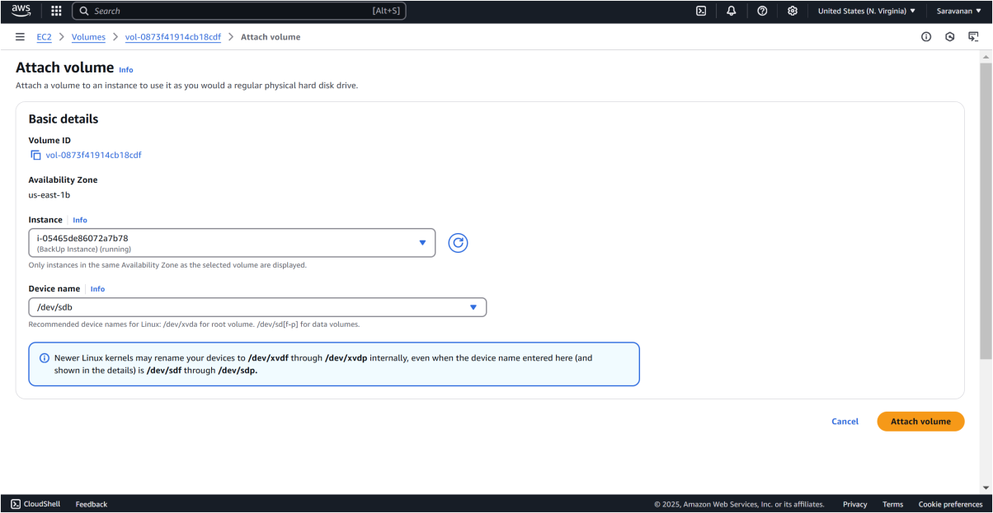

## Step 4:

Instances>EBS>Snapshots

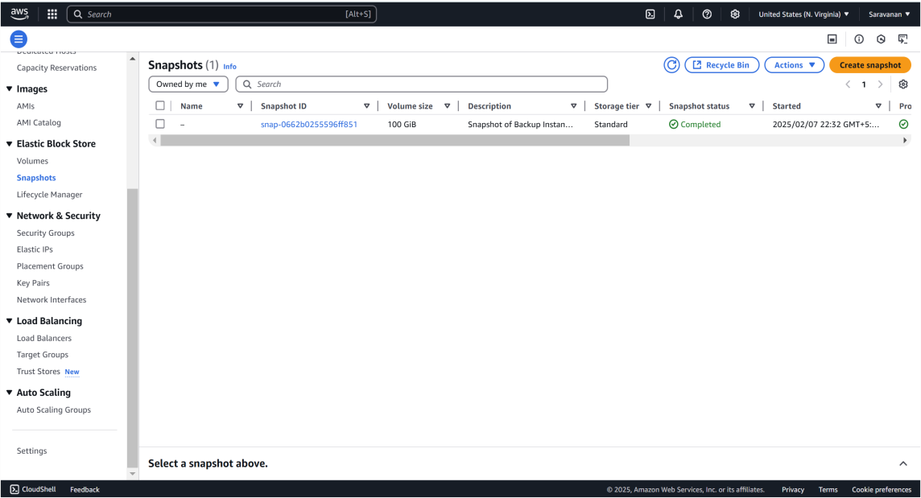

## Step 5:

Action>Terminate(delete)instance is used for used for stopping the running of the instance

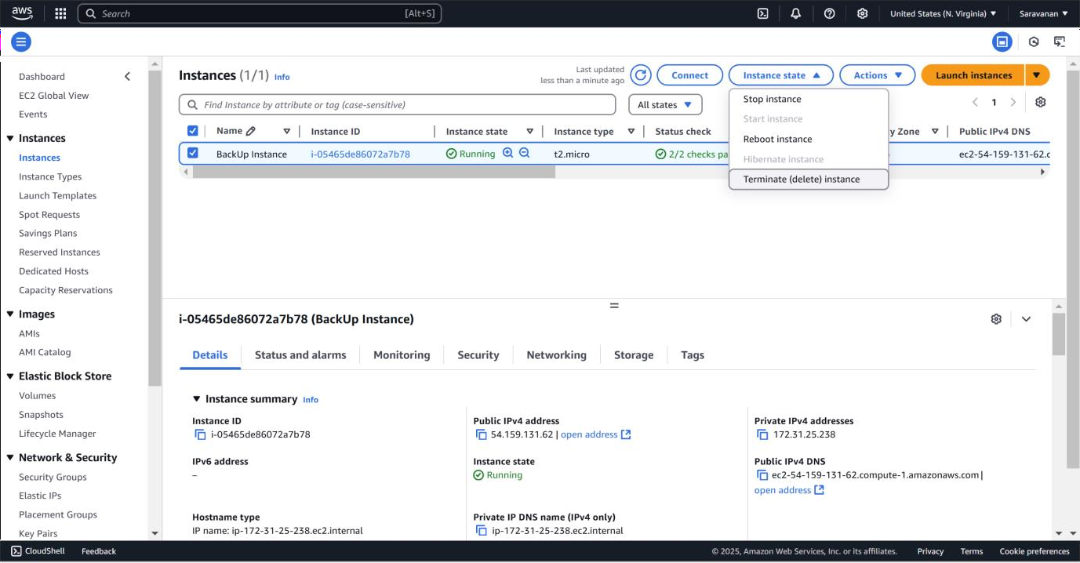

## Step 6:

Snapshots are located in the left menu of the instance page under EBS(Elatic Block Storage where in the action you can create volume from subnet and you can do snapshot settings and so on

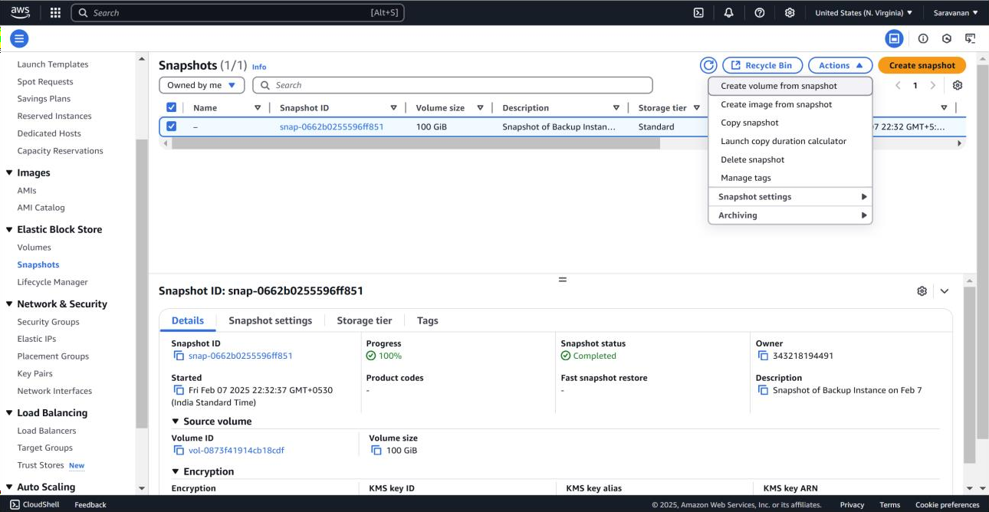

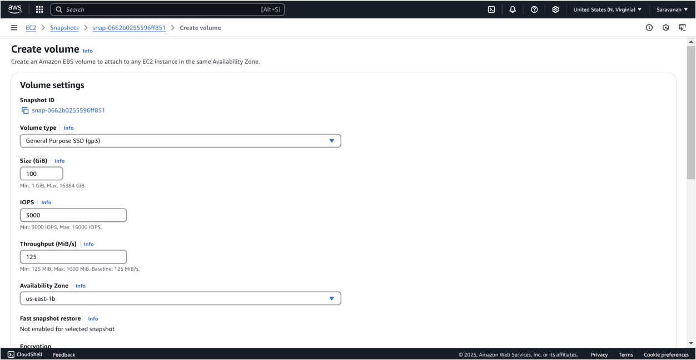

## Step 7:

* For launching instance we do the usual way in which we have to choose any OS of your choice ,use free tier eligible t2.micro and the rest are all the same . don’t forget to use key pair

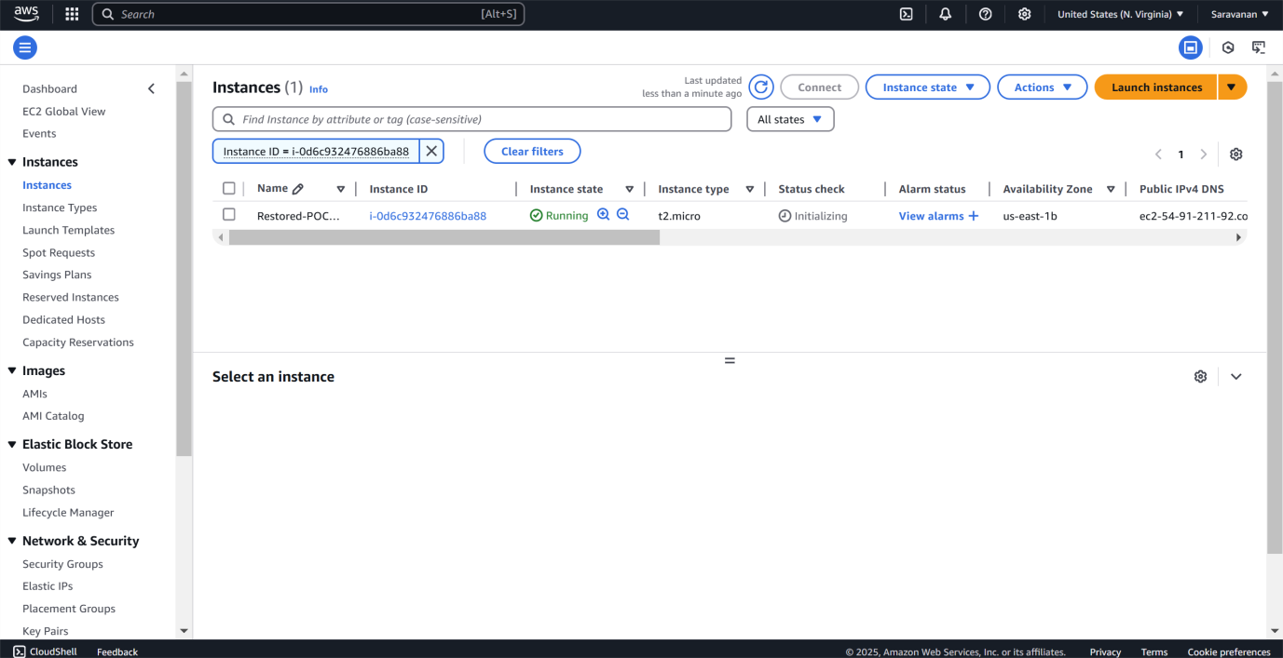

## Step 8:

Here you do both in which you attach the instance by the action and stop the instance by using instance state

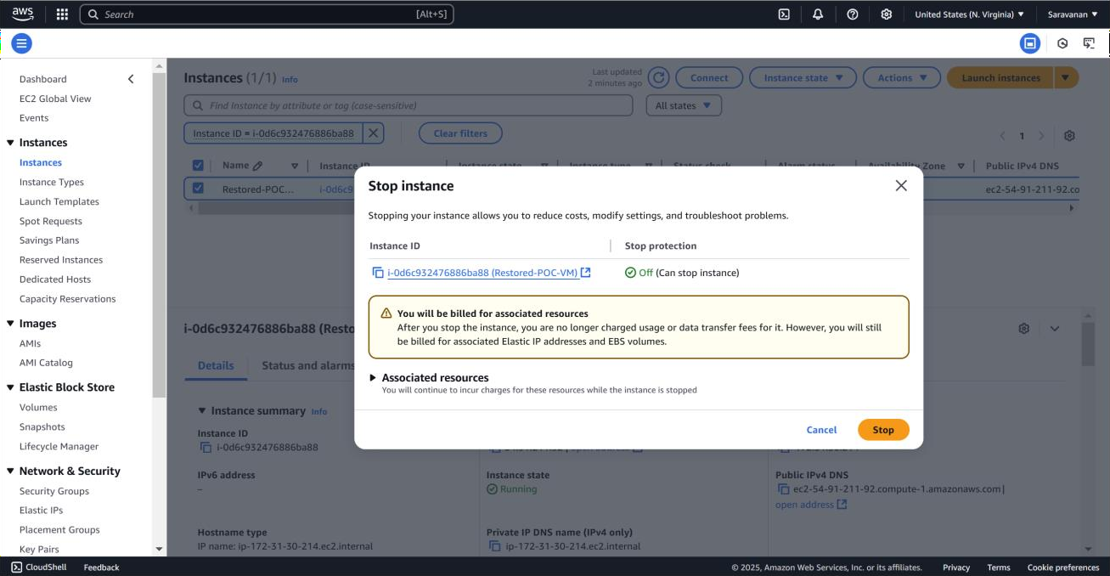

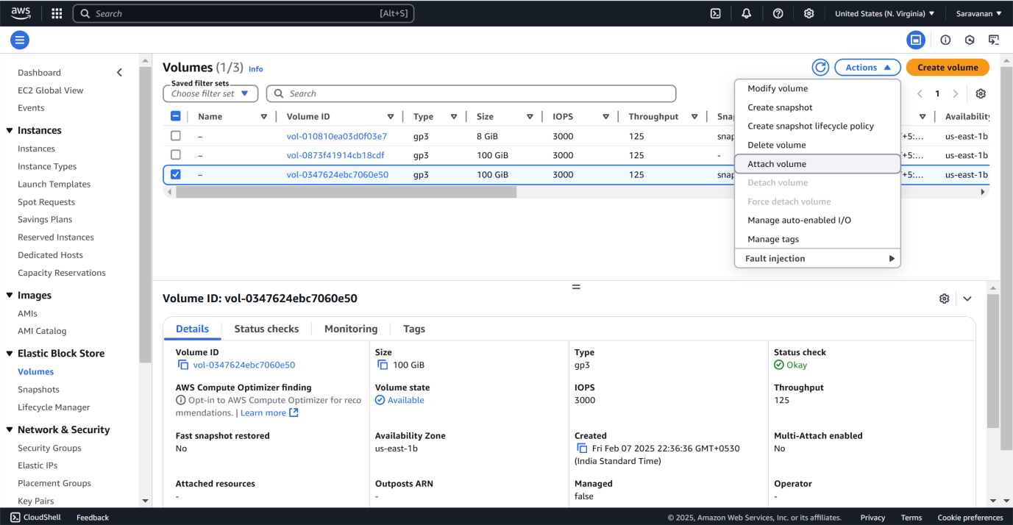

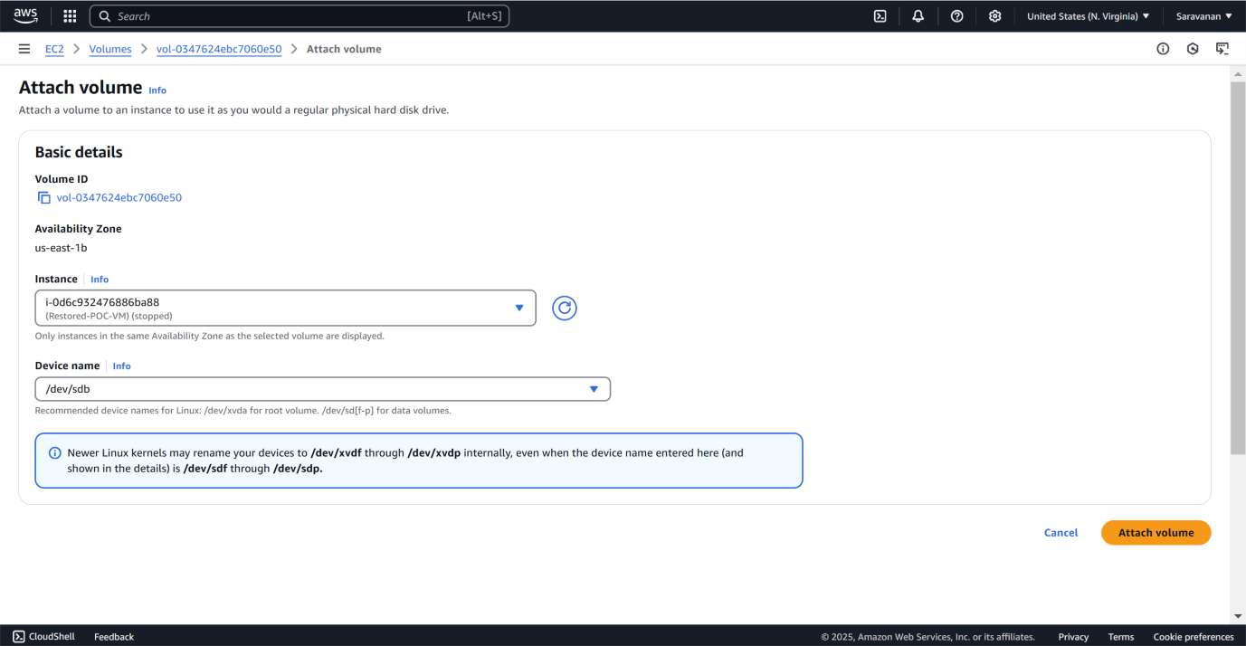

**Outcome**

* Successfully creating and managing cloud VM snapshots.
* Restoring a terminated VM from a snapshot without data loss.
* Enhancing disaster recovery preparedness and business continuity.
* Gaining experience in cloud-based backup and restoration techniques.